

ME 559 Project Fall 2018 – Plate with hole

A report prepared for

Prof. Kaan Inal

Waterloo, Ontario

Maharshi Patel (20577876)

4A Mechatronics Engineering

December 3, 2018

Table of Contents

List of Figure 3

Introduction 4

Model Geometry 4

Case 1: Fixed at Left End and Force/Pressure on the right 5

Model Generation 5

Mesh Generation 5

Boundary and Physics Conditions 6

Simulation Run 6

Post Processing 7

Mesh Independence 8

and Relationship 9

Case 2: Steel Pin at Hole and Force/Pressure at Right End 10

Model Generation 10

Mesh Generation 10

Boundary and Physics Conditions 10

Simulation Run 11

Post Processing 11

Mesh Independence 11

and Relationship 12

Conclusion 12

References 13

## List of Figure

Figure 1: Plate with a hole example 4

Figure 2: Dimension of the plate with a hole 5

Figure 3: A typical 8-node hexahedron element mapping x, y and z to and [1]fe 6

Figure 4: Initial ANSYS run for Case 1 7

Figure 5: Two plots that show the relationship of A/W to Kt [2], [3]. 7

Figure 6: The first mesh refinement approach, using ANSYS's basic refinement 8

Figure 7: The second approach was mesh refinement 8

Figure 8: Final approach on mesh refinement 8

Figure 9: Convergence in the value as number of elements are increased 9

Figure 10: SolidWorks Model for case 2 10

Figure 11: Boundary conditions for case two 10

Figure 12: Initial run for case two 11

Figure 13: Graph showing the with respect to A/W [2], [4]. 11

Figure 14: Convergence in the value as number of elements are increased 12

# Introduction

For Engineers stress concentrations are point of interest as they are one of the key features that helps to predict system failure. However, trying to analytically derive them for various design is fairly complex, and most of the time impossible. This is where FEM comes into the aid. FEM is a very power full tool that helps predict stress concentration using various numerical methods. The solution will not be exact to that of an analytical solution, however for engineering purposes it can suffice or meet expectations. Stress concentration factor is defined as follows, equation [1].

|  |  |  |
| --- | --- | --- |
|  |  | [1] |

When running a FEM model, it is very critical to know the boundary conditions, the project scope, and the limitation of the tools that are being used. Thus, in this project that major focus will be on the model setup, explanation on assumptions that were made, mesh convergence test.

# Model Geometry

For this project the geometry and loading constraints are as follows:



Figure 1: Plate with a hole example

The material used in the simulation for the plate is isotropic Aluminum. The plate has a finite width , and a thickness , that has the ratio of:

|  |  |  |
| --- | --- | --- |
|  |  | [2] |

The hole is centered at:

|  |  |  |
| --- | --- | --- |
|  |  | [3] |

In addition the ratio between has to be between:

|  |  |  |
| --- | --- | --- |
|  |  | [4] |

There will be two load cases simulated in this report. First, being fixed at the left end, and pressure applied in the right. Second, steel pin support at the hole, and again pressure applied in the right direction.

# Case 1: Fixed at Left End and Force/Pressure on the right

## Model Generation

In this scenario the following dimension were chosen for simulation and created in SolidWorks:

|  |  |  |
| --- | --- | --- |
|  |  |  |

Note that the dimension for the width and length were chosen so that the reference stress is established.

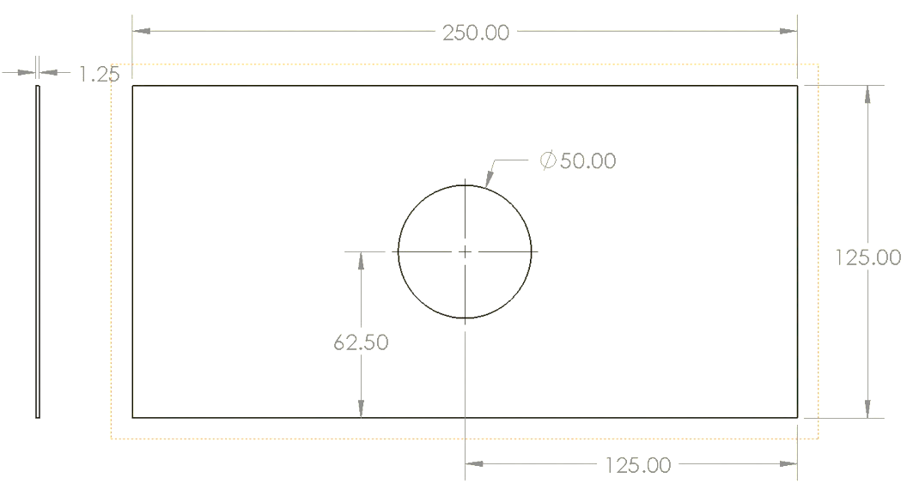

Figure 2: Dimension of the plate with a hole

Once the geometry was defined, it was imported into ANSYS AIM 18.1. Shown in figure X.

## Mesh Generation

From here, the internal mesh generation module was used built the mesh on the plate. The mesh that was used in this analysis was an 3D 8-node brick/hexahedral element. This element has 6-DOF, 3 for translational and 3 for rotational. This element is over compensated for the problem definition, but since the problem is not computational heavy, the focus was to see how that element would work and resolve the problem. However, do note that it is generally recommended to use more lower order elements that to use higher order. Shown below is an example of an 8-node hexahedron element, Figure 3.

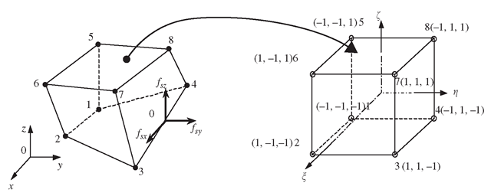

Figure 3: A typical 8-node hexahedron element mapping x, y and z to and [1]fe

The element shape function are as follows [1]:

|  |  |
| --- | --- |
| http://what-when-how.com/wp-content/uploads/2012/06/tmp589670_thumb2.png | [5] |

## Boundary and Physics Conditions

After, meshing, the boundary conditions and physics properties were applied, shown in FIGURE BELOW. The plate was given standard material property of Aluminum, the values shown in table X below. This is based on the generic material model from ANSYS. In addition, the boundary condition of fixed support left end and pressure of , in the positive x-direction was applied. In this, problem that could be possible added enhancement of symmetry, in the x and y direction.

## Simulation Run

Once the physical model was derived, the static model was then ran to solve the problem. The result from the first test is shown below.



No. of Nodes: 1958

No. of Elements: 249

Max. Stress: 95088

Figure 4: Initial ANSYS run for Case 1

As seen above the stress is building up where expected, top and bottom of the hole. This is very similar, to the analytical solution, hence is can be safe to assume that the solution of this numerical model is valid.

## Post Processing

As seen above, the relationship between can be used to calculate the , can be calculated as:

|  |  |  |
| --- | --- | --- |
|  |  | [6] |

Thus, based on this simulation the .

Using equation [1] and [6], . Now, that is derived it’s time to calibrate and validate the model in the simulation. It’s always nice to have the simulation return a stress value based on the conditions, however there is a need for an engineering judgement call to make sure that the result makes sense. The way this simulation can be validated is from using charts that show the relationship between and this loading scenario. These plots are derived from using experimental values, hence real-world values. Thus, this is the best way the model can be validated. Shown below are the two plots that show the stress concentration factor, Figure 5.

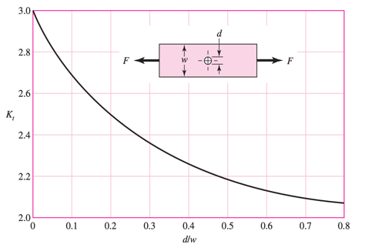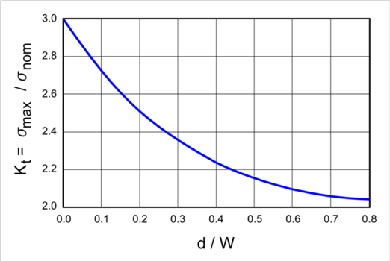

Figure 5: Two plots that show the relationship of A/W to Kt [2], [3].

Thus, from approximating the value from the graph and comparing the value obtained from the simulation there is a percentage error of . This value was obtained from calculating percentage based on the actual , using equation [7], and the value derived from simulation.

## Mesh Independence

Getting a solution from the simulation is good. However, making the solution mesh independent is really critical. For the reason that, coarse mesh will not capture all the phenomena that are occurring in the model. So, creating the mesh finer and finer will generate a better solution. Hence, this is where the tradeoff between computation power and the accuracy of the results come into play. Knowing, when to stop refining the mesh for marginal gain is an engineering judgment, however this leads the solution to be mesh independent. And so keeping this in mind 3 more simulation were created to show the mesh independence shown below Figure 6, Figure 7, Figure 8.

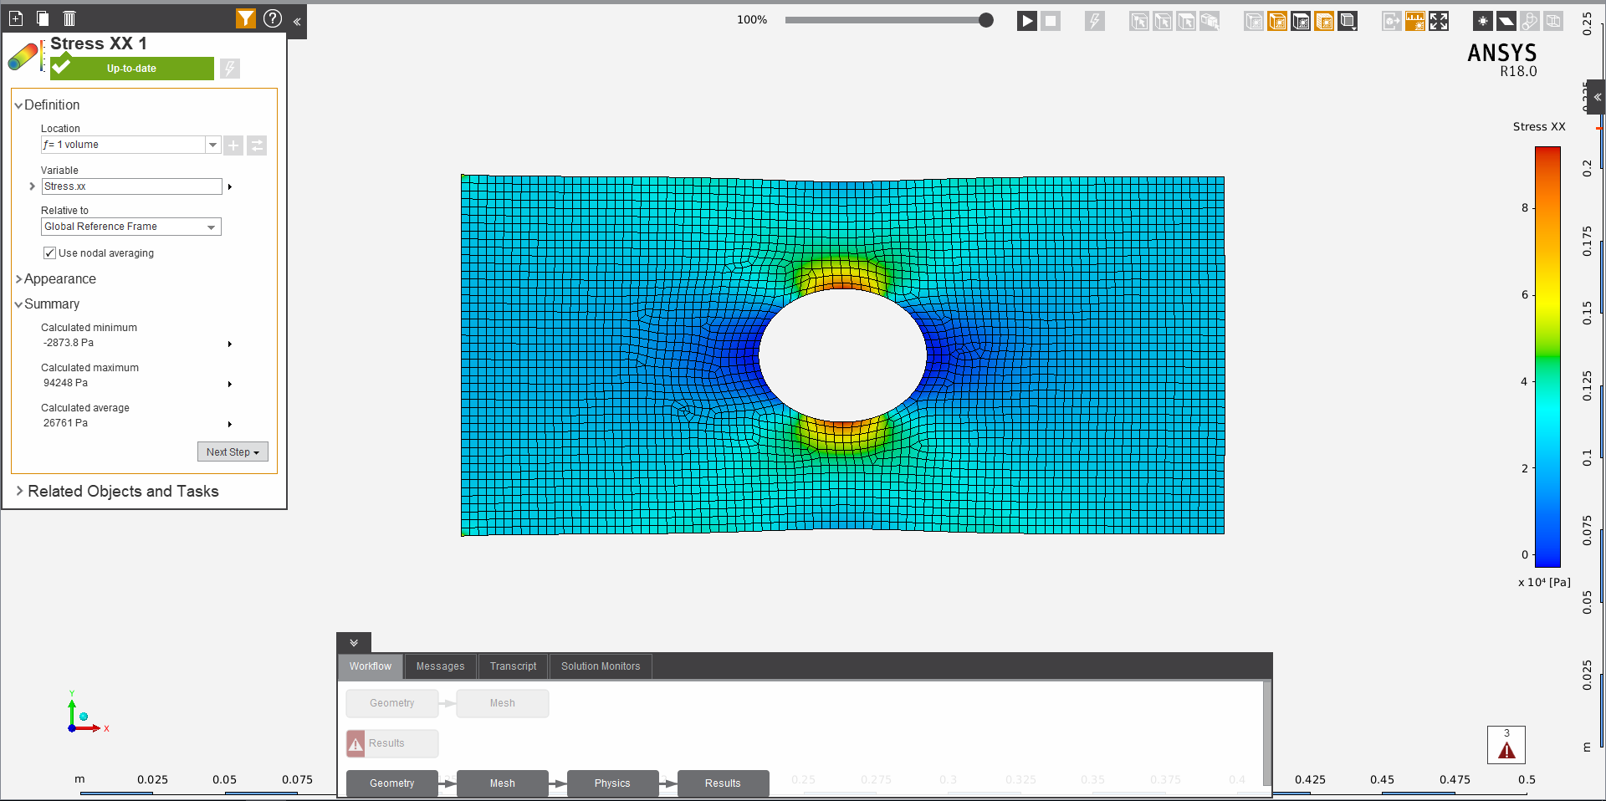



No. of Nodes: 26612

No. of Elements: 3500

Max. Stress: 94248

Figure 6: The first mesh refinement approach, using ANSYS's basic refinement

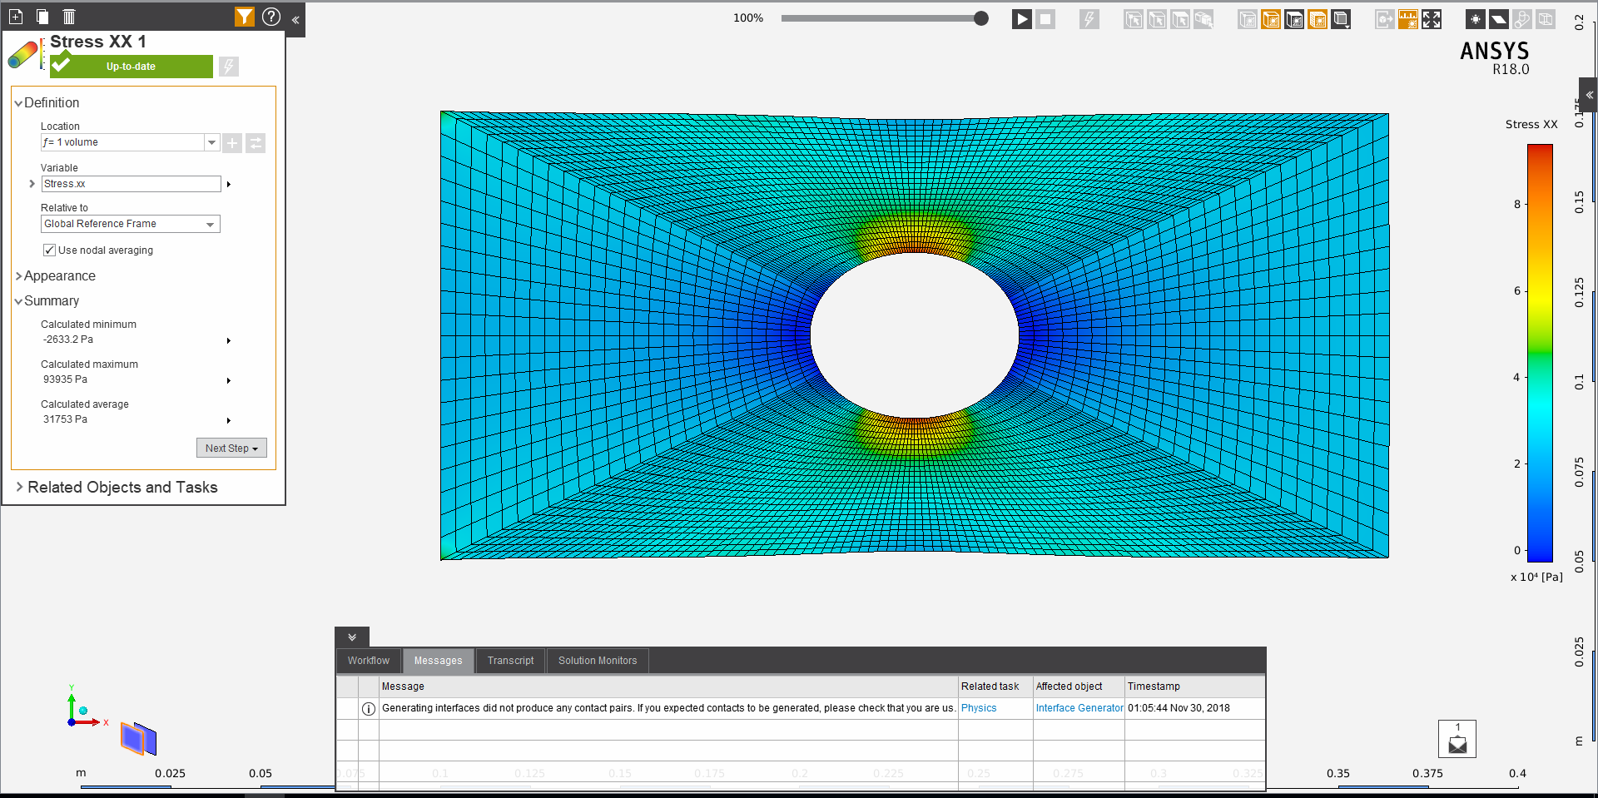

No. of Nodes: 43200

No. of Elements: 6000

Max. Stress: 93935

Figure 7: The second approach was mesh refinement

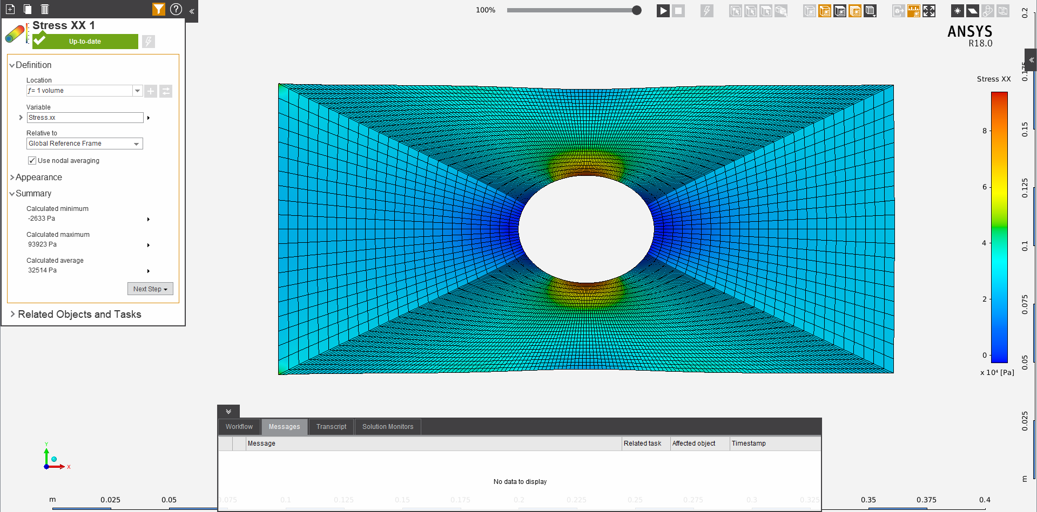

No. of Nodes: 61200

No. of Elements: 8500

Max. Stress: 93923

Figure 8: Final approach on mesh refinement

As seen above, this mesh is better in many ways than a generic mesh that is produced by ANSYS. In the last two iteration, Figure 7 and Figure 8 there are no elements that are triangular. This preserves the consistency of the mesh build. In addition to this, more importance was given to the top and bottom part of the hole. This is so, these two areas are critical in calculating the , because this is where the maximum stresses occur. Based on these results, a mesh convergence plot was derived. And the relationship between and number of elements was plotted. As shown the value converges around 2.25.

Figure 9: Convergence in the value as number of elements are increased

## and Relationship

This simulation is done for only one , choice. As for to gain an understanding on the relationship between and , this method needs to be conducted for multiple in order to achieve similar points on the Figure 5.

Once, the simulations have been conducted and validated and also deemed to be mesh independent, then these points can be curve fitted to achieve the relationship between and . This is how the relationship curve can be derived and plotted. In order to derive the theoretical equation that maps the ratios well, choose is 4 set of ratios, one on the lower spectrum 0.01, one on the high spectrum 0.75 and two point in between for example 0.25 and 0.50. This way there is a broad spectrum that could be derived, and they could be easily curve fitted.

In this report this has not been derived due to time constraint. However, here is a numerical equation derived from experimental values, equation [7], [3].

|  |  |
| --- | --- |
|  | [7] |

Since, the depends only geometrical property rather than material property. It can be assumed to say that the equation [7], can be used at the relationship curve to obtain the .

# Case 2: Steel Pin at Hole and Force/Pressure at Right End

## Model Generation

The model dimensions remain the same, however now there is a pin. Shown below, Figure 10.

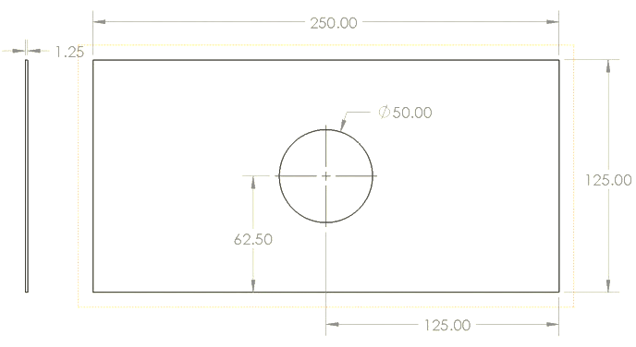 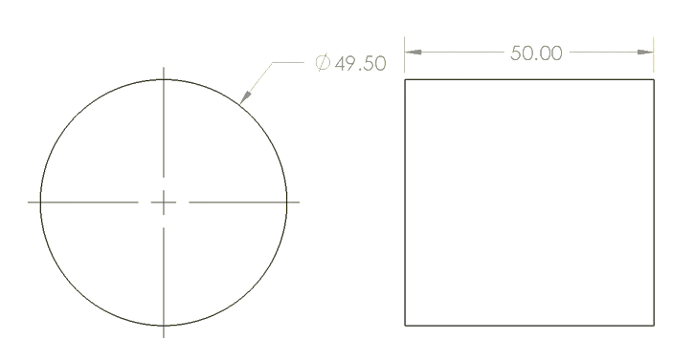

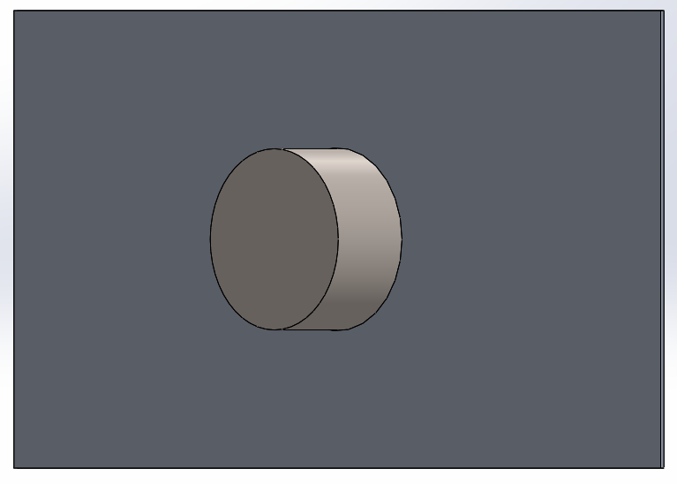

Figure 10: SolidWorks Model for case 2

## Mesh Generation

Same mesh formulation was used as in Case 1.

## Boundary and Physics Conditions

For this case, the boundary conditions are as follows:



Pin Support

Figure 11: Boundary conditions for case two

Here the support type and location changed. However, the force/pressure applied remained the same in magnitude and location. For the material properties, contact surfaces they all remain the same, the only added volume was the pin and its material to be steel.

## Simulation Run

Hence, here is the initial simulation result for the problem.

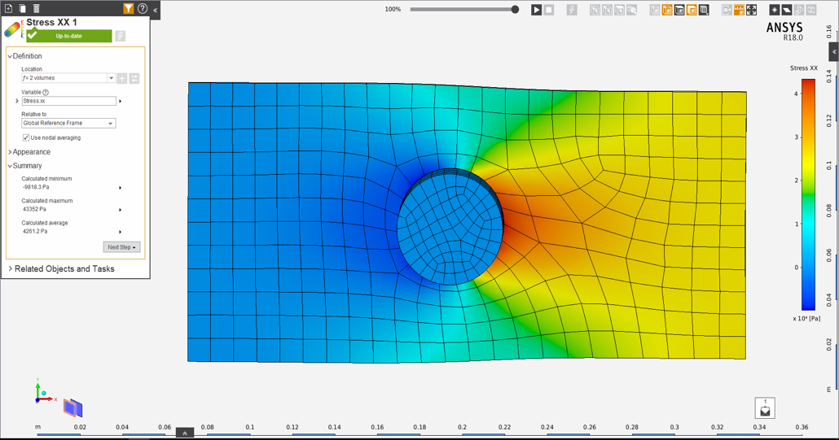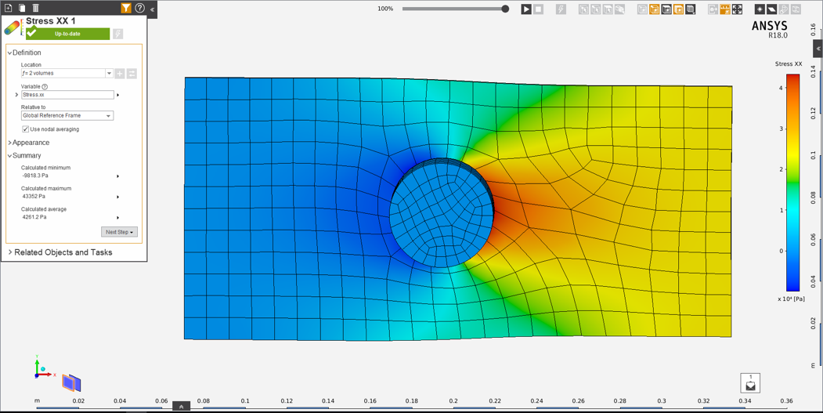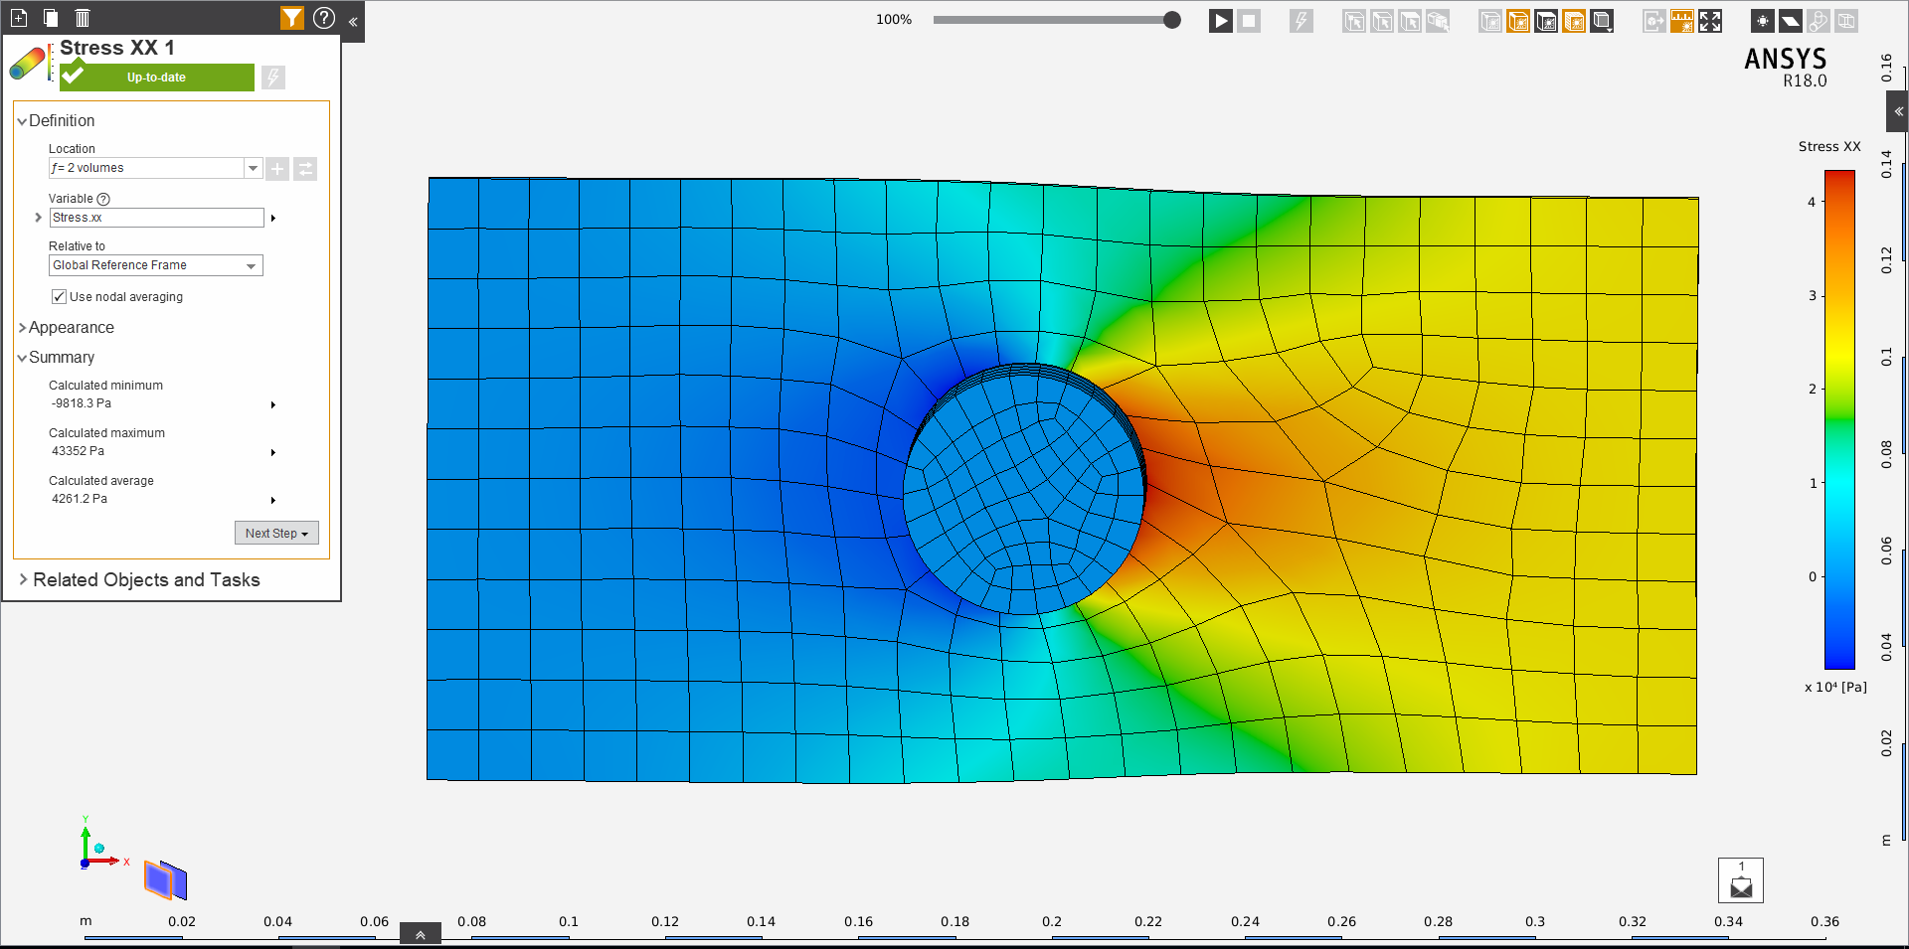

No. of Nodes: 3083

No. of Elements: 440

Max. Stress: 43322

Figure 12: Initial run for case two

As expected the stresses are on the right side of the pin. This is because, the left pin is taking no load as it hits the rigid pin. Hence, the stress profile can be validated.

## Post Processing

Form the simulation results, follow the same procedure to find . Hence, using the equations [1] and [6], can be derived to be 3.1. This value is very similar to the actual derived in from actual experimentation, Figure 13. Do note that this case has the overall values are typically higher than that of the values in first case. The percentage error is calculated with the same format, as it turns out to be 10%.

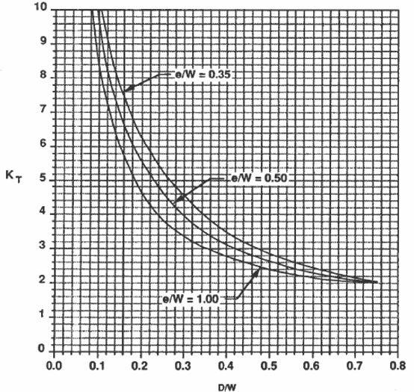 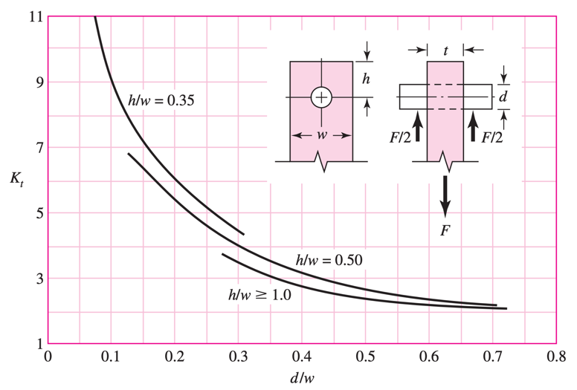

Figure 13: Graph showing the with respect to A/W [2], [4].

## Mesh Independence

Just like the first case mesh independence will be done in order to validate the model. Similar approach was taken in order to validate the model. Shown below, in Figure 14, is the convergence result.

Figure 14: Convergence in the value as number of elements are increased

## and Relationship

As shown in case 1, the same exact approach should be taken in order to derive the equation. Hence for this equation, the plots (Figure 13) should be used. With these two plots the derivation can be done using curve fitting through the line. Hence, using the Engauge digitizer, and curve fitting the plots, the equation is as following:

|  |  |
| --- | --- |
|  | [8] |

# Conclusion

Final thoughts on this simulation is that, it is very critical to understand stress concentration that occur within your geometry. It is also important to understand that when simulating the models, there should be a way to validate it, and should be mesh independent. As for the loading condition, it is very much preferable to have the 1st case than 2nd case due to lower stress concentration factors. With enough time, and relationship should also have been derived. However, the plots given can also be used to find the function.

In addition, this problem could have been solved using symmetry and 2D approximation, however, since the problem was fairly simply to iterate through the focus was on using 3D domain.

# References

[1] “FEM for 3D Solids (Finite Element Method) Part 2.” [Online]. Available: http://what-when-how.com/the-finite-element-method/fem-for-3d-solids-finite-element-method-part-2/. [Accessed: 03-Dec-2018].

[2] “Charts of Theoretical Stress-Concentration Factors K * t.”

[3] “Stress Concentrations at Holes.” [Online]. Available: http://www.fracturemechanics.org/hole.html. [Accessed: 03-Dec-2018].

[4] T. Nguyen, “MSC Software Confidential MSC Software Confidential Stress Around Bolt Hole Comparison Between A Closed Form Calculation Method and Finite Element Analysis Results 2013 Regional User Conference,” 2013.